Proceedings of JRC 2005
2005 Joint Rail Conference
March 16 – 18, 2005, Pueblo CO
RTD2005-70019

Cutting Traction Power Costs with Wayside Energy Storage Systems
in Rail Transit Systems

Louis Romo  Vycon Inc. | David Turner  Turner Engineering Company | L.S. Brian Ng, P.E.  Brian Ng Engineering, Inc.

Abstract
New electrically propelled passenger trains use AC propulsion with induction traction motors and variable voltage, variable frequency drives. Benefits include higher performance, reduced starting energy use, regenerated braking energy, lower maintenance, and a broadened range of operating conditions. However, some Transit Operators have found that new trains have not fully delivered the economic benefits of regeneration.

An effective Energy Storage System (ESS) can capture the full energy savings benefit of regenerative braking and will reduce the peak power usage which incurs high peak power demand charges. Candidate ESS technologies include flywheels, supercapacitors, and batteries. This paper provides a set of typical requirements for a transit wayside ESS, and evaluates the strengths and weaknesses of the candidate technologies against the requirements.

Primary ESS benefits are energy savings and peak power reduction. The authors calculated potential savings for a generic ESS at two typical transit systems: a dense US heavy rail system with 10-car trains, and a US light rail line that runs trains of two to four Light Rail Vehicles (LRVs). In the heavy rail case study, a properly sized ESS will provide energy savings of up to 4.4 kWH per train start/run/stop cycle. This is a savings of 3.6 MWH per day per ESS, or 21% of the total energy. In the light rail case study, ESS will reduce the peak power demand by up to 119 kWH/H, or 23% of the total peak demand.

introduction
In the US and around the world, new electrically propelled heavy rail train-sets and LRVs use AC propulsion with induction traction motors and variable voltage, variable frequency drives. Benefits of these AC trains over older trains include higher performance, reduced starting energy use, regenerated braking energy, lower maintenance, and a broadened range of operating conditions. However, Transit Operators have found that without an ESS available to capture the regenerated power, AC trains and earlier DC chopper trains have not fully delivered their potential economic benefits.

Transit Operators have growing interest in finding an Energy Storage System (ESS) solution to capture the full energy savings benefit of regenerative braking and to reduce the peak power usage which incurs high peak power demand charges.

Existing ESS technologies include flywheels, supercapacitors, and batteries. Transit Operators have installed ESSs on the wayside and in some cases on individual railcars or electric locomotives. See Figure 1.

This paper provides a set of typical requirements for a transit wayside ESS, and evaluates the strengths and weaknesses of the candidate technologies against the requirements. Finally, it presents three transit case studies with quantified energy and power savings.

Figure 1 Transit Energy Storage System
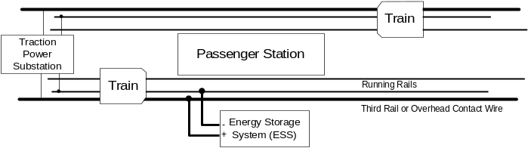

ESS Energy Saving Objectives
Transit Operators expect ESSs to meet two key energy saving objectives:

1] Reduce Total Energy Consumption: The ESS must capture and enable reuse of energy regenerated by braking trains. This directly reduces the Transit Operator’s energy costs. Importantly in Kyoto Treaty countries, ESS also delivers a quantified reduction in carbon dioxide emissions.

2] Reduce Peak Power Demand Charges: The ESS must reduce peak power demand charges. Electric utilities in North America and Europe charge industrial customers for peak power demand, in addition to charges for total energy used.

Peak power demand is determined by the time period(s) with the highest energy usage. Each electric utility sets a time period, which is typically one or two intervals of five, fifteen, or thirty minutes duration. Power demand charges during peak hours of the peak season are as much as five times higher than during base periods. Some Transit Operators report that their peak power demand costs are higher than their total energy use costs. The peak power demand is calculated by dividing the energy used in the peak period by the duration. The units are kWH / H, or just kW.

Reducing the energy used during these peak demand periods can deliver significant cost savings. An ESS that captures train braking energy and enables its reuse will reduce the peak power demand charge.

Additionally, some Transit Operators need an ESS to provide traction power voltage support to fix traction power voltage sag problems. Voltage sag results from physical limitations of the traction power supply including substation location, rating, and loads. It can also occur as new trains or extended operations overload existing traction power supplies; for example, higher density service, a line extension, or the introduction of a new fleet of higher performance AC or DC chopper trains. A suitably located ESS can supply current near the train when it is needed, decreasing the voltage drop so that operations are not disrupted.

ESS Energy Saving Requirements
To fulfill these objectives, a transit wayside ESS must capture and enable reuse of train braking energy which would otherwise be lost, and it must reduce the trains’ peak power demand on the traction power supply.

For major urban rail lines, the ESS must operate at a high duty cycle during long rush hours with close headways. In practice, this means the ESS must operate at a duty cycle near or above 40%. In other words, it must discharge 10 s, idle for 15 s, charge for 10 s, idle for 15 s, and repeat the cycle indefinitely.

The ESS must handle the peak braking and acceleration power and energy of the Transit Operator’s trains. The required power and energy varies dramatically between a suburban one or two-car LRV line and an urban ten-car heavy rail line. The control algorithm must capture the regenerated energy, accommodating the changing pattern of train arrivals and departures.

To provide an acceptable return on investment, the ESS must be completely automatic, maintenance-free, self-protecting during emergency or failure conditions, and highly efficient with very low waste energy.

As with all transit equipment, the ESS must be safe for staff and the public under all normal and abnormal conditions, including when maintenance staff are working on the traction power or third rail equipment. The ESS must be stable under all conditions and electromagnetically compatible with the Transit Operator’s signal system and other equipment.

The ESS must permit low-cost installation and therefore must fit in existing spaces, with minimal heating and cooling requirements. The ESS must also be easily connected to the traction power system.

ESS Technologies
Transit Operators have evaluated and tested flywheels, supercapacitors, and batteries for transit ESS application. Table 1 summarizes the advantages and obstacles for each. Following sections describe each technology in detail.

Table 1 ESS Technology Comparison
Feature | Flywheel | Supercap | Battery
Energy density |  |  | 
Cost / kWh |  |  | 
Power density |  |  | 
Cost / kW |  |  | 
Maintenance needed |  |  | 
Configurable rating |  |  | 
Operating life |  |  | 
Proven technology |  |  | 
Hazardous materials |  |  | 
Now in service |  |  | 
Key:  Better  Average  Worse

Supercapacitor ESS
Supercapacitors store energy in the electric field between two very closely spaced plates. Compared to the chemical storage in batteries, supercapacitors can transfer power quickly, without ion migration rate limitations. A leading supercapacitor technology uses double-layer capacitors (DLCs) with high surface area, providing 2,400 F of capacitance in a volume of only 30 cu in (0.5 l). A typical application uses approximately 1,300 capacitors in a capacitor module. A supercapacitor ESS (SESS) connects capacitor modules in series and parallel to achieve the needed voltage rating, power output, and energy content. A DC to DC converter regulates the flow of energy into and out of the SESS. Applications include transit wayside and railcar ESS, wind power, uninterruptible power supplies (UPS), pulsed power systems, and space missions.

A key SESS advantage is that SESS has no moving parts, and is suited to railcar or wayside applications. SESS requires little maintenance. SESS cost per kW is lower than batteries but higher than for flywheels. SESS can be designed for deep, continuous charge/discharge cycles.
However, SESS has higher cost per kWH than battery ESS (BESS) or flywheel ESS (FESS). SESS contains dielectric fluids which are typically both toxic and flammable. This presents a considerable burden for Transit Operators, who strongly prefer to minimize materials and equipment risks. Hazardous failure modes occur if the capacitors are subject to an overvoltage.

SESS capacitor life strongly depends on voltage stress. Long operating life can be achieved in a capacitor design with low power and energy density by reducing the capacitor voltage. Low capacitor voltage requires many capacitors in series to achieve the necessary operating voltage, resulting in increased cost, volume, and maintenance and decreased reliability.

Several companies sell commercial supercapacitor devices and modules, and are now developing and demonstrating wayside and railcar mounted SESS systems. [6] [7] [8] Projects are under way in Portland OR (US), Koln and Dresden (Germany), and Madrid (Spain).

Battery ESS
Batteries store energy in a reversible chemical reaction. Batteries have stored and delivered energy since the first electrical devices were discovered, and have shown continued if slow advances in characteristics and performance in each decade and generation. A DC to DC converter regulates the flow of energy into and out of the BESS. Important applications include hybrid cars and buses, uninterruptible power supplies, space missions, solar and wind power, and portable electronics. Battery technology is mature yet expanding, with a broad range of devices and modules available from many well-established manufacturers.

Compared to FESS and SESS, BESS has enormous energy capacity with low unit cost per kWH, which is why batteries provide work in the highly popular hybrid car and bus applications. However, batteries have a high cost per kW, so the transit BESS challenge is to provide a high enough power rating without an unnecessarily large and expensive energy capacity. BESS has not met this challenge to date.

New generations of high performance lithium ion and other advanced batteries provide great service in cellphones and laptops. However, these batteries are too costly to provide the hybrid vehicle or transit BESS power requirement. Lead acid, nickel cadmium, and nickel metal hydride batteries are the cost-competitive solutions.

As with SESS, batteries have low cell voltage, so a BESS requires many cells in series, impacting cost, volume, maintenance, and reliability. Also, since BESS stores energy chemically, the ion migration rate limits the power rating and causes a strong temperature dependence. Batteries have a short life and require high maintenance when compared to flywheels or supercapacitors. Battery electrolytes are usually toxic and corrosive. BESS cannot provide deep, continuous charge/discharge cycles without sharply reduced battery life. Life and performance are also reduced by temperature extremes.

Flywheel ESS
A flywheel is a mass rotating about an axis which mechanically stores kinetic energy. A FESS stores electrical energy by accelerating a motor and a connected mass. In modern flywheels, the rotating mass is typically integrated with the motor rotor. The FESS motor operates in generator mode to remove mechanical energy from the rotating mass and deliver electrical energy. A converter controls the electrical transformation from variable frequency AC, which runs the motor, to DC which powers or is supplied to the train in most heavy rail and light rail systems. Modern FESS technologies use steel or composite rotors, high performance insulated gate bipolar transistors (IGBTs) and digital signal processor (DSP) controllers, magnetic bearings, and high power density motor-generators. [3] Typical applications include transit ESS, wind power, uninterruptible power supplies, pulsed power systems, and space missions. A FESS installation can consist of one or more FESS units connected in parallel.

A key FESS advantage is that it can provide deep, continuous charge/discharge cycles without wear or degradation. FESS has a low cost per kW. FESS cost per kWH is higher than commodity batteries but lower than supercapacitors.

A FESS operating life of 20 years is practical for the rail application, and can be highly reliable with little maintenance, especially if equipped with magnetic bearings. FESS is useful for the highest availability applications including spacecraft. [1] [2] [4] FESS equipped with a steel flywheel mass is less affected by extreme temperatures than other ESS technologies.

FESS also has limitations. As noted above, FESS has a higher cost per kWH than commodity batteries. Placing a FESS unit on a railcar must accommodate the gyroscopic reaction force when the FESS spinning axis is rotated. The FESS design must resolve safety concerns about energy containment in case of flywheel or bearing failure. Since FESS is a mechanical device, it is more susceptible to moving part failures than supercapacitors or batteries. Finally, some FESS designs present a greater challenge to achieve effective cooling at reasonable cost.

A number of companies sell FESS for UPS and various other applications, and there have been recent demonstration projects in the transit industry at New York City Transit, London Underground, Paris, Lyon, and others. Both wayside and railcar demonstration projects are under way. [2] The highest rated unit demonstrated to date is a 1 MW, 7kWh FESS, and larger units are now under development.

Traction Power Costs
Payments to electric utilities for electric energy and peak power demand are a significant operating expense for Transit Operators. Energy and peak power costs fluctuate and trend over time in response to complex market, regulatory, commercial, and political forces. Table 2 is a snapshot of U.S. utility rates during summer 2004. These rates are used to calculate cost savings in the case studies below.

Table 2 Energy and Power Costs
 | East Coast | West  Coast
Energy Cost | $0.07 / kWh | Variable by time of day and season:  ~$0.08 / kWh base  ~$0.13 / kWh during summer peaks
Peak Power Demand Cost | ~$7.0 / kW monthly charge, set by the maximum half hour of peak demand in the month | Variable by time of day and season: [1]  ~$0.34 / kW monthly charge for the max half hour  Plus ~$0.70 / kW monthly charge during Partial Peak hour  Plus ~$7.5 / kW monthly charge during summer Peak hour.
Note [1] Definitions of Peak and Partial Peak hours depend on the season. In a typical summer work day, Peak hours are 12 noon to 6 pm, and Partial Peak hours are 8:30 am to 9:30 pm.

Energy Savings Case Study Approach
The authors developed and used a Traction Power Cost Analysis (TPCA) tool to evaluate ESS savings. The TPCA models the power flow between the traction power supply, the train, and the ESS. Inputs include the train acceleration and braking current and voltage profiles versus time, as well as operating characteristics for the rail line including schedule, train length, and headway.

The ESS power rating is an adjustable parameter which is used to select and optimize the ESS configuration. The TPCA assumes the ESS fully meets the requirements listed above, up to its rating limit. To simplify calculations, the TPCA uses train regenerated energy as an input, and constrains the energy returned by the ESS to balance the input quantity. The TPCA calculates the energy used by the train and saved by the ESS, per car per stop/start cycle. The TPCA extends the calculation to cover the rush hour, day, and year. It also calculates the average power used in the peak power demand interval. Finally, it calculates the resulting costs and savings.

The authors used TPCA to calculate energy and power savings for two US rail lines:
- A dense east coast heavy rail line with ten car trains and a two minute headway. The electric utility typically uses the two biggest fifteen minute intervals to calculate peak power demand.
- A west coast suburban light rail line with two to four car trains and a fifteen minute headway. The electric utility typically uses a five minute interval to calculate peak power demand.
The authors also use published data on energy and power savings from a recent SESS demonstration in Koln, Germany. [6]

Case Study Results
All traction power savings result from the capture and reuse of train regenerated energy. The peak power demand is too long for the reduction of instantaneous power to translate directly into a reduced peak power demand charge.

Therefore, two sets of real-world parameters govern ESS effectiveness in energy and peak power demand savings:
1. The power and energy characteristics of train regenerative braking.
2. The ESS power and energy ratings compared to the train’s characteristics.

Data on train regenerative braking indicates there is significant variation in train regeneration effectiveness not related to line receptivity. Maximizing traction power cost savings requires effective train regeneration under a broad range of conditions.

The ESS power rating and energy capacity must be big enough to capture a significant portion of the regenerated train energy. For ESS to capture energy when two trains arrive at the same time, the ESS ratings must be up to twice as big.

For a two-track line, there is no benefit to an ideal ESS rating larger than that needed to capture regenerated energy from two trains. However, a larger energy capacity enables ESS to work in less than ideal conditions, and to provide both traction power savings and voltage support.

Figures 2 and 3 show power and energy profiles versus time for the train, ESS, and substation, for the US heavy rail line and light rail line. The train power profile versus time is from typical field measurement data. The TPCA calculates the power captured and returned by an ESS with the selected power rating. The substation curve shows the traction power supply output, which is the difference between the train usage and the ESS supply. The energy curves are the corresponding time integrals of the power curves. Table 3 summarizes the results.

The light rail line with a 15 minute headway has long periods where the traction power system has no load. For the light rail line, ESS delivers a larger percentage reduction in peak power demand reduction and energy saving, with a smaller ESS power rating. However, the energy savings is much larger for the heavy rail line because it uses much more energy. The model suggests that the heavy rail line may be able to save more energy with a modified regeneration control scheme.

Figure 2 ESS for East Coast Heavy Rail
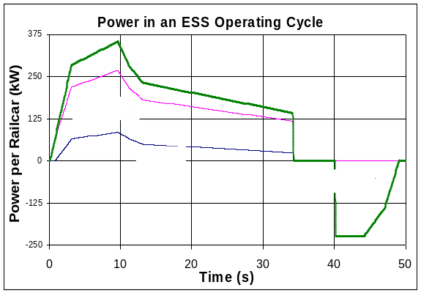

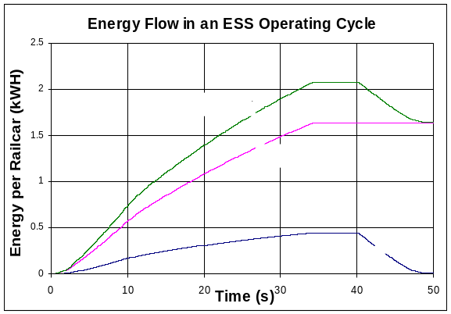

Figure 3 ESS for West Coast Light Rail
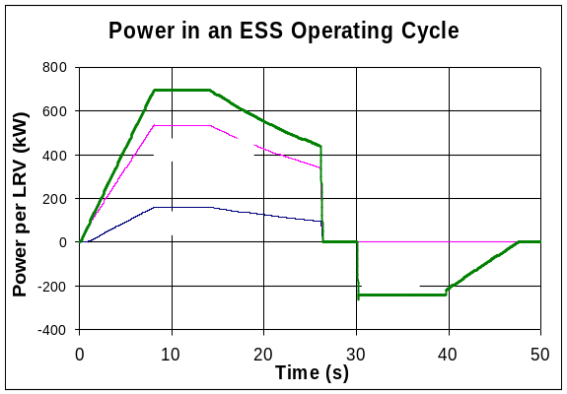

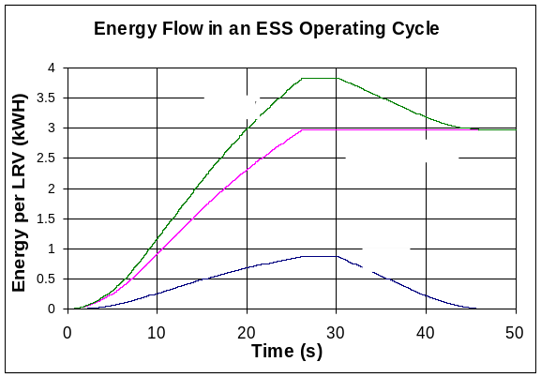

Table 3 ESS Results Summary
 | US East Coast  Heavy Rail | US West Coast  Light Rail | German Light Rail
Train length | 4 to 10 | 2 to 4 | 1 to 2
Operating hours per day | 24 | 20 | 20
Rush hour headway | 2 min | 15 min | 10 min
Train load assumption | AW2 | AW2 | Actual load
ESS Rating | 2.5 MW | 0.6 MW | 0.6 MW
Projected energy per cycle w/o ESS | 21 kWH (10 car train) | 9.6 kWH [1] | Not reported
Energy recovered per cycle | 4.3 kWH (10 car train) | 2.2 kWH [1] | Not reported
Energy recovered per cycle | 21% | 23% | Not reported
Energy recovered per ESS per day | 3.5 MWH | 0.23 MWH | Not reported
Energy Saving per Year | $74,000 | $7,600 | Not reported
Peak power demand period | 15 min | 5 min | 15 min
Peak Power Demand w/o ESS | 1,200 kW | 830 kW | Not reported
Peak Power Demand Reduction | 130 kW | 100 kW | 55 kW [2]
Peak Power Demand Reduction | 11% | 12% | Not reported
Power Savings per year | $22,000 | $5,900 | Not reported
[1] For daily average train length of 2.5 cars
[2] Average of 6 days measurements

For the modeled heavy rail line with ten-car trains at a seated passenger load, a properly sized ESS of 2.5 MW rating will provide energy savings of up to 4.3 kWH per train start/run/stop cycle, for an energy savings of 21 % compared to a cycle with no regeneration. This equates to a savings of 3.5 MWH per day per ESS or 1.05 GWH per year. Using the Table 4-1 energy costs, this is a savings of $74,000 per ESS installation.

The ESS will reduce the peak power demand averaged over a fifteen minute interval for 10-car trains on two tracks, from 1.21 MW to 1.08 MW per train for a per-train savings of 130 kW. This 11% peak power demand reduction yields a savings of $22,000 per year. Thus the total potential savings per year per ESS is $96,000, minus maintenance costs.

The modeled light rail line has a smaller power demand and therefore would require a smaller ESS. It has trains of two to four cars depending on time of day, with a day-long average train length of 2.5 cars. With a seated passenger load (AW2), a 0.6 MW ESS will provide energy savings of up to 2.2 kWH or 23% per train start/run/stop cycle. This yields a savings of 0.23 MWH per day per ESS or 75 MWH per year. This is a savings of $7,000 per ESS installation.
ESS peak power demand reduction, averaged over a five minute interval for four-car trains on two tracks, is 100 kW, reduced from 0.83 MW to 0.73 MW, or 12% of the total peak power demand.

Table 3 also presents results reported for measurements at a SESS installation in Koln Germany. The light rail line operates with one or two car trains on ten-minute peak hour headways. Reference [6] reports the SESS achieved a peak power demand reduction of 55 kW, from measurements taken over six days. This measurement is consistent with the TPCA analysis.

Next Steps
Transit Operators need measurement data demonstrating the energy and peak power demand savings provided by ESSs. Transit Operators and ESS suppliers are organizing projects to demonstrate, qualify, place in service, and measure benefits from ESSs. Following initial demonstrations and measurements, Transit Operators and ESS suppliers will have the opportunity to build more capable ESS and railcar systems, capable of delivering important energy, cost, and environmental improvements for the transit system users.

Acknowledgments
The authors thank the transit agency engineers and managers who have recognized the challenge and who are leading the work to capture the full energy and power saving benefits that AC trains offer.

References

[1] “Flight test demonstration of a flywheel energy storage system on the International Space Station,” J. Edwards, et. al., Boeing Defense & Space Group, Seattle, WA. Aerospace and Electronics Conference Proceedings NAECON 1997.

[2] “Flywheel energy storage system for traction applications,” M.B. Richardson, Urenco Power Technologies, Capenhurst UK. Power Electronics, Machines and Drives, 2002. International Conference.

[3] “Flywheel technology: past, present, and 21st century projections,” J.G. Bitterly, US Flywheel Systems, Newbury Park, CA. IEEE Aerospace and Electronic Systems Magazine, August 1998.

[4] “Hybrid battery and flywheel energy storage system for LEO spacecraft,” B.G. Beaman, GM Space Power Applications. Branch, NASA Goddard Space Flight Center, Greenbelt, MD. Thirteenth Annual Battery Conference on Applications and Advances, Jan 1998.

[5] “A supercapacitor-based energy-storage substation for voltage-compensation in weak transportation networks,” A. Rufer et. al., Swiss Federal Institute of Technology, Lausanne, Switzerland. Power Tech Conference Proceedings, 2003 IEEE Bologna.

[6] “Static Energy Storage Systems based on Double-layer Capacitor technology,” W. Gunselmann and C. Godbersen, Siemens Transportation Systems, 2003.

